Local Green Space Description and Evidence, as shown in CNDP Map 3 and 3a – Local Green Space

Proposed New Local Green Spaces as shown on CNDP Map 3a.
Muriel's Meadow - Breadsell Lane, Crowhurst, East Sussex TN38 8EB Grid Reference OS 772122
The meadow is 0.595 hectares and is bordered by three Public Rights of Way CRH/4/2. CRH/21/4. CRH/20/4, stream and typical Wealden deciduous woodland
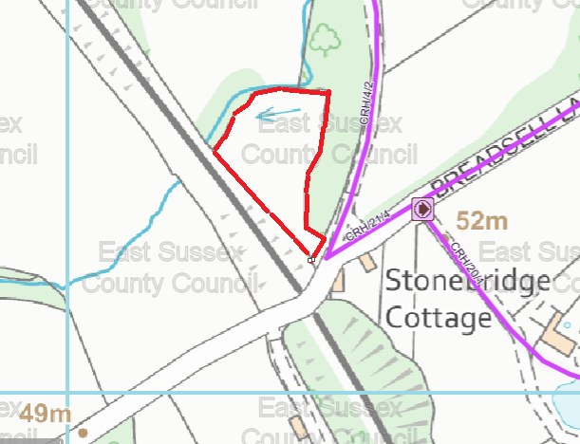
Registered as a wildlife asset in the Crowhurst Biodiversity Audit, it lies in the High Weald AONB and is typically characteristic of lowland meadows.

The meadow is currently privately owned and was purchased approximately 30 years ago.

In 2018 the landowners, as keen environmentalists, felt that they were no longer able to manage the meadow and asked that the Crowhurst Environment Group (CEG) take on its management and develop it as a traditional wildflower meadow able to be enjoyed as a community resource by local people.

It is bequeathed to Sussex Wildlife Trust by the landowner to ensure it remains as a community wildlife asset and will continue to be managed by local volunteers until that time.

In 2022, Sussex Wildlife Trust agreed to take on the long term management of the Meadow due to its ecological value as a restored wildlife meadow and richness of its wildlife. The landowner has given consent to the Meadow being designated as a Local Green Space as part of our revised Neighbourhood Development Plan

Value as a community wildlife asset:
In 2019, CEG, an unincorporated voluntary group, was formed made up of local residents seeking to fulfill a key aspiration of the Crowhurst Neighbourhood Development Plan (2019) to conserve, enhance and monitor the natural environment and assets of the Parish.

Following the 2019 Climate & Ecological Emergency Resolution of Crowhurst Parish Council, the CEG gained designation wildlife status of local verges (that included Muriel’s Meadow) as important wildlife habitats. Although not a verge it is adjacent to a lane.

A Sussex Lund grant was awarded for the purpose of returning the land to traditional wildflower meadow to be used as a community resource of environmental significance which would be managed by local volunteers.

Over the past 4 years the Meadow has continued to be managed as a wildflower meadow, using traditional meadow management by groups of local volunteers who have learnt traditional skills in order to do so, such as scything.

The Meadow has now achieved a high level of biodiversity. .Although a small site it is rich in biodiversity and getting richer the more it is managed and surveyed.

New hedging was also planted by resident volunteers as part of the i Dig project. Sheep from a Crowhurst animal rescue centre graze the meadow in the autumn and winter months which rescue donkeys had grazed before.

A butterfly survey is carried out 3 times a year by RSPB Fore Wood volunteers. Regular wildlife surveys also take place by Dr John Feltwell, local ecologist and members of CEG.

The Meadow has special significance to the local community due to its beauty, peaceful location, richness of wildlife and as a shared community space. .Its community value also lies in the involvement of local people in its restoration and ongoing management as a traditional wildflower meadow in the High Weald.

An information board has been installed adjacent to the Meadow with information for local residents with regular updates to Crowhurst villagers in the monthly newsletter. It is a community asset at the heart of one of the quieter places of the parish.

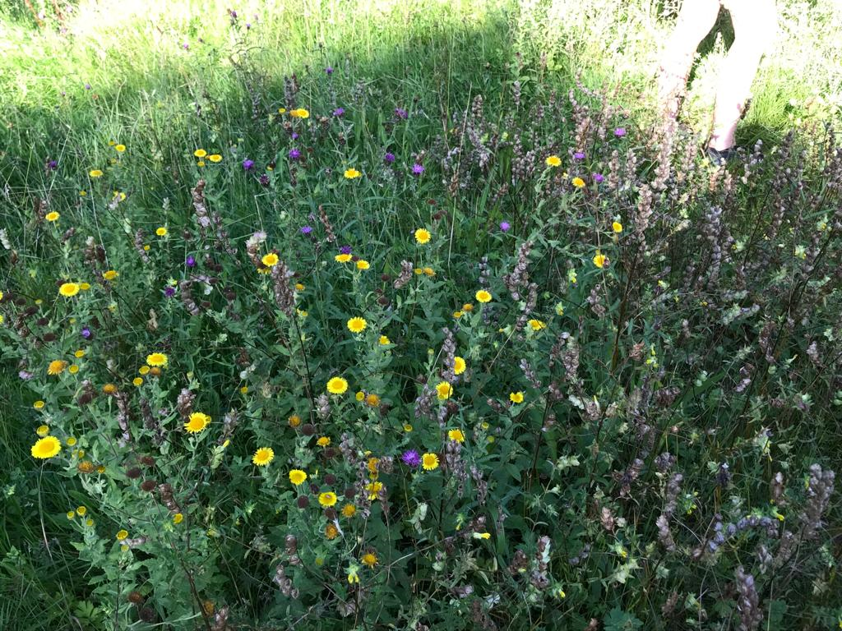

Cinderbrook ( TN33 9AL, 50.88N, 0.499E)
Cinderbrook is an existing prominent open space in the centre of the Village. Until recently a grazing field, it is now arable land but crossed by a public right of way. It is enclosed by extensive hedgerows, which form important wildlife corridors and habitats, providing essential linkage for flora and fauna. It is crossed by two important watercourses, the Rackwell and Powdermill Streams, the latter draining from the historic 1066 battlefield. It is a tranquil area, rich in biodiverse aquatic invertebrates and birdlife, owing to the streams.
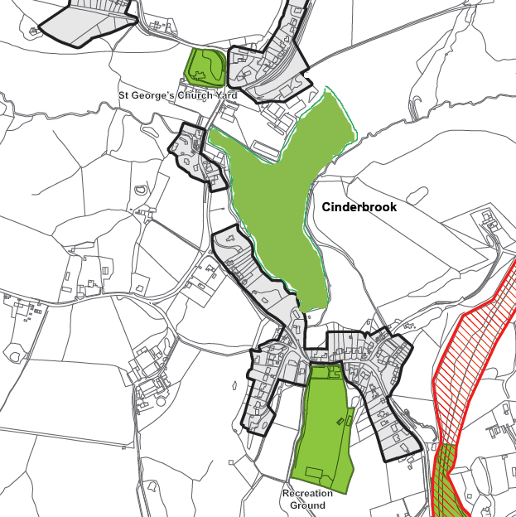
The area is crossed by a significant footpath, part of the historic 1066 Country Walk, a unique PRoW.
This footpath also serves to connect the two key village hubs and their adjacent residential areas. The community hub to the north west comprises the school, village hall, church and ancient ruin. To the south is the recreation ground, youth club, preschool and pub. This footpath is both a distinctive feature of the landscape and an important connection between the two village centres. This substantial green space perfectly connects the two halves of the community; residents of both halves constantly criss-cross the green space for getting about and recreation.
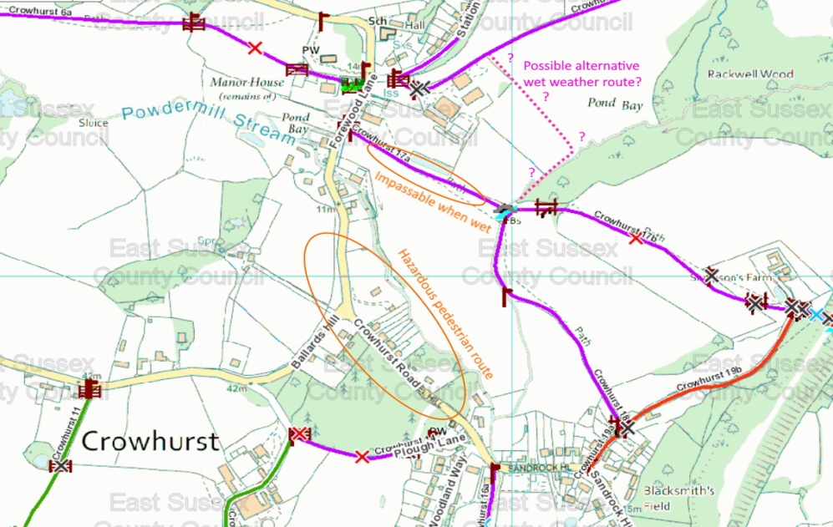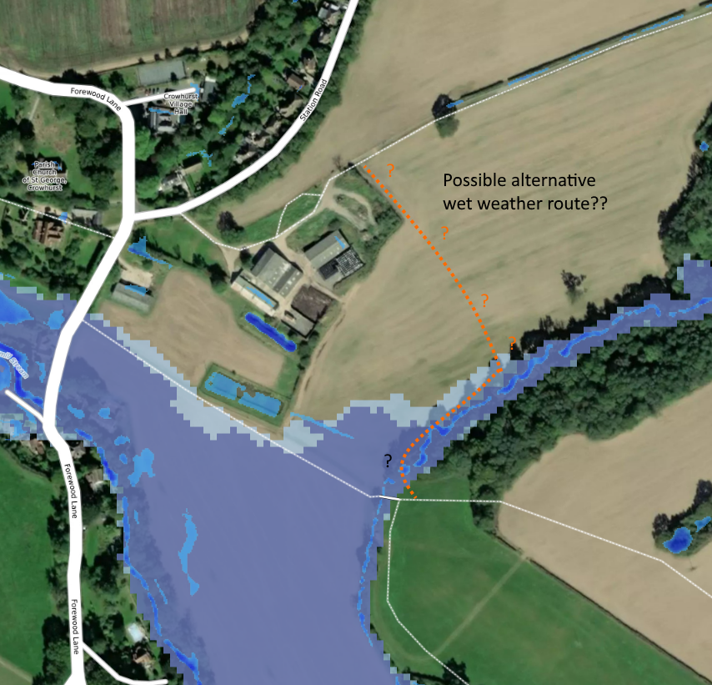
It is the intention as part of this Plan, to strengthen the footpath route, thus enhancing the walking experience of pedestrians. Because the land is low-lying, it is liable to become muddy and it is proposed to either relocate the footpath or provide an additional alternative footpath across the higher ground in the northern part of this space. This would increase the usage of this route and make its value as a communication channel between the two parts of the Village even more important. It would strengthen the ability of residents from the northern part of the Village to access the recreational and other facilities on the southern side and residents on the southern side to more readily access the church, school and village hall, without having to drive, thus saving carbon emissions. It would also enable walkers to avoid the road, which links the two centres and which, in places lacks footpaths, thus increasing safety.

Cinderbrook also has an important function in separating the two village centres and settlement areas. Retaining this separation is an essential component in maintaining the rural character of Crowhurst, as described in the Crowhurst Parish Landscape Character and Sensitivity Assessment (2023). It is readily accessible to the village community and is in immediate proximity to the community it serves. Its open aspect affords attractive views of the heritage centre and adjoining woodland, which overlook it.

Cinderbrook’s setting in the surrounding High Weald landscape, within the High Weald AONB makes it a distinctive village focal point. For these reasons, Cinderbrook is special to the community and of great local significance.

Local Green Spaces as shown an CNDP Map 3 - unchanged from Made CNDP 2019
 | Greenspace Location | Description and Purpose/type | Quality and Condition | Value and benefit to community | Other e.g statutory designations
GS1 | RSPB Fore Wood Nature Reserve | Woodland – mix of deciduous and ancient. RSPB Nature reserve | Regularly maintained and fit for purpose | Well used by local walkers and bird enthusiasts. | Ancient woodland; Nature reserve; AONB; part of it is an SSSI; Deciduous woodland (Priority Habitat)Rich in Wildlife; Tranquil
GS2 | St Georges Churchyard | Cemetery. Still in use and containing ancient graves. Trees provide homes for bats, birds and insects. Many of the stones are rich in lichen and offer opportunities  for lizards to bask in the sun. The wildflowers are pronounced in spring and in the  wilder areas during summer. | Sensitively maintained to support biodiversity. Contains an ancient Yew (between 1000 and 2000 yrs old) plus other historic trees. | Historic value; Tranquil; Beautiful and rich in wildlife | AONB; Contains several significant trees as mentioned in Environment Description ENV Map 9.
GS3 | Recreation Ground | Open field for recreation use (Football, cricket and other sports) with a play area and small car park. Also Youth Club facilities. Powdermill stream runs down Western edge. Hedgerows to all other sides. | Regularly maintained and well used by the community and surrounding areas. | Sport and recreational use and community activities such as village fayre, youth and other events. Important views down Combe Haven Valley. | Protected as recreation space. In DaSA proposed extension to Strategic Gap
GS4 | Crowhurst Nature Reserve (Quarry Wood) | Deciduous (PH) woodland within sandstone quarry along disused Bexhill to Crowhurst railway line. Ancient woodland to its Eastern side. | Well maintained as a Local Nature Reserve (owned by residents through Crowhurst Society Charitable Trust.) | Tranquil and Beautiful; Rich in wildlife and flora with important ferns. Valued by community as both an educational area (regular events held) and for walking. Wildlife corridor links with Sampsons Lane woodland. | AONB; Nature Reserve supported by Powdermill Trust and Sussex Wildlife.

